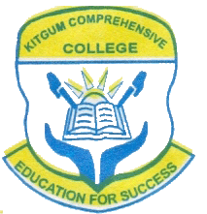 **Name………………………………………...…………………...Sign…………….**

**BIOLOGY**

(Theory)

**Paper 1**

**MARCH 2024**

*1 hour*

***Uganda certificate of Lower secondary education***

**S.3 MID-TERM I ASSESSMENT 2024**

BIOLOGY

(Theory)

**Paper 1**

1 hour

**INSTRUCTIONS**

* *This paper consists of* **one** questions which is **compulsory.**

1. Otim, a S.2 student ate a meal consisting of an egg, cooked cassava and ground nuts during his breakfast. After eating his breakfast, Otim went back to class for his mid-morning lessons.

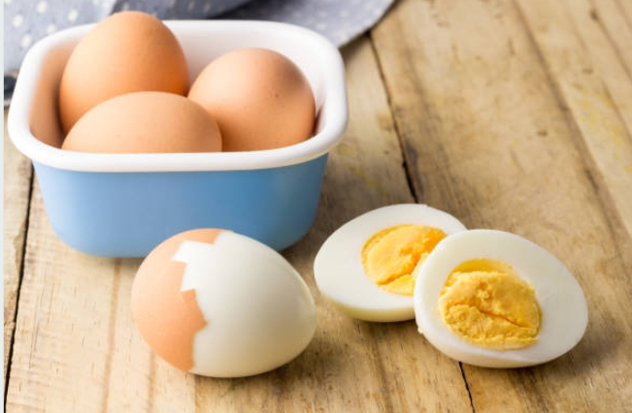 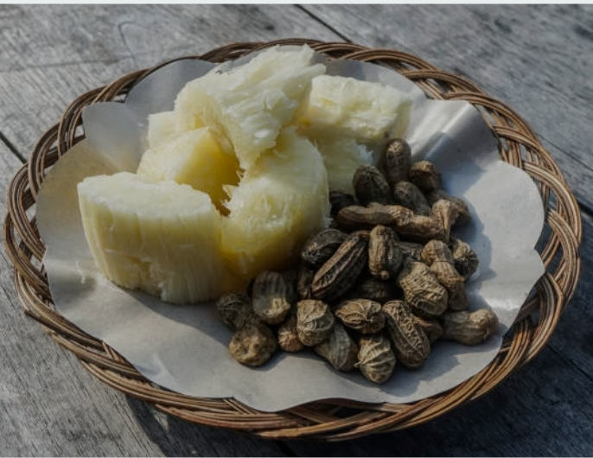

1. As a student who has acquired knowledge about how animals obtain their food, ingest it, digest it and final products of digestion absorbed; help Otim understand how the meal he ate was broken down in the body until when the final products of digestion were absorbed. (Scores 15)
2. Complete digestion of food eaten by Otim and absorption of the products of digestion occurs in his ileum. Clearly explain to Otim how his ileum is adapted to carry out its functions. (scores 08)
3. Guide Otim on understanding how his body uses each absorbed products of digestion of the food he ate. (Score 07)

**==END==**